Zero Knowledge Proof (ZKP) is an encryption scheme originally proposed by MIT researchers Shafi Goldwasser.
Zero-knowledge protocols are probabilistic assessments, which means they don’t prove something with as much certainty as simply revealing the entire information would. They provide unlinkable information that can together show the validity of the assertion is probable.
Currently, a website takes the user password as an input and then compares its hash to the stored hash. Similarly a bank requires your credit score to provide you the loan leaving your privacy and information leak risk at the mercy of the host servers. If ZKP can be utilized, the client’s password is unknown the to verifier and the login can still be authenticated. Before ZKP, we always questioned the legitimacy of the prover or the soundness of the proof system, but ZKP questions the morality of the verifier. What if the verifier tries to leak the information?

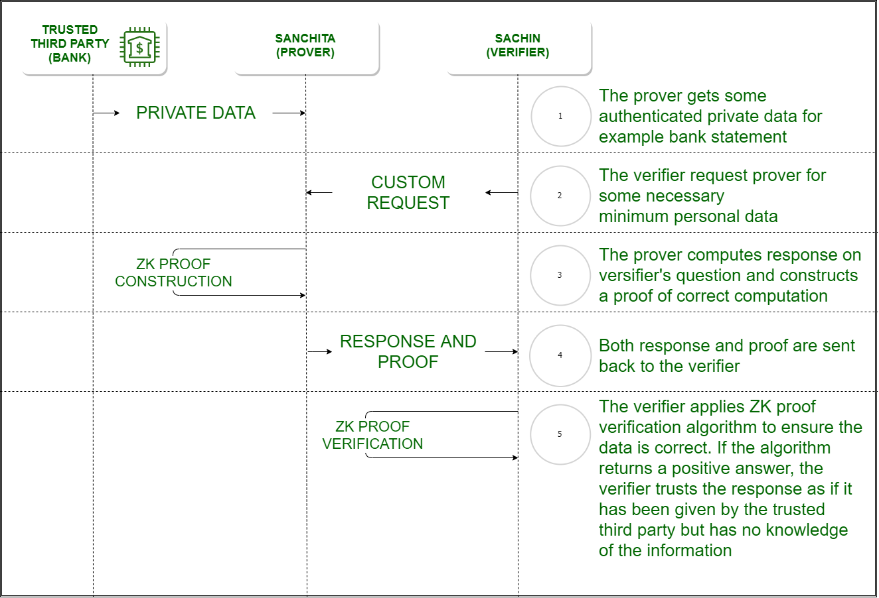

Example-1: A Colour-blind friend and Two balls :
There are two friends Sachin and Sanchita, out of whom Sanchita is colour blind. Sachin has two balls and he needs to prove that both the balls our of different colour. Sanchita switches the balls randomly behind her back and shows it to Sachin who has to tell if the balls are switched or not. If the balls are of the same colour and Sachin had given false information, the probability of him answering correctly is 50%. When the activity is repeated several times, the probability of Sachin giving the correct answer with the false information is significantly low. Here Sachin is the “prover” and Sanchita is the “verifier”. Colour is the absolute information or the algorithm to be executed, and it is proved of its soundness without revealing the information that is the colour to the verifier.

Example-2: Finding Waldo :
Finding Waldo is a game where you have to find a person called Waldo from a snapshot of a huge crowd taken from above. Sachin has an algorithm to find Waldo but he doesn’t want to reveal it to Sanchita. Sanchita wants to buy the algorithm but would need to check if the algorithm is working. Sachin cuts a small hole on a cardboard and places over Waldo. Sachin is the “prover” and Sanchita is the “verifier”. The algorithm is proved with zero knowledge about it.

Properties of Zero Knowledge Proof :

- Zero-Knowledge –If the statement is true, the verifier will not know that the statement or was. Here statement can be an absolute value or an algorithm.
- Completeness –If the statement is true then an honest verifier can be convinced eventually.
- Soundness –If the prover is dishonest, they can’t convince the verifier of the soundness of the proof.
Types of Zero Knowledge Proof:

- Interactive Zero Knowledge Proof –It requires the verifier to constantly ask a series of questions about the “knowledge” the prover possess. The above example of finding Waldo is interactive since the “prover” did a series of actions to prove the about the soundness of the knowledge to the verifier.

- Non-Interactive Zero Knowledge Proof –For “interactive” solution to work, both the verifier and the prover needed to be online at the same time making it difficult to scale up on the real world application. Non-interactive Zero-Knowledge Proof do not require an interactive process, avoiding the possibility of collusion. It requires picking a hash function to randomly pick the challenge by the verifier. In 1986, Fiat and Shamir invented the Fiat-Shamir heuristic and successfully changed the interactive zero-knowledge proof to non-interactive zero knowledge proof.

What is public key infrastructure (PKI)?
Public key infrastructure (PKI) governs the provisioning of digital certificates to protect sensitive data, establish digital identities, and secure communications.
Oct 27 2023Rich Dubose
Enterprises leverage Public key infrastructure (PKI) to encrypt, decrypt, and authenticate information between servers, digital identities, connected devices, and application services. PKI is used to establish secure communications to abate risks to data theft and protect proprietary information as organizations increase their reliance on the internet for critical operations. This post will explore how public key cryptography enables related keys to encrypt and decrypt information and guarantee the integrity of data transfers.
What is a cryptographic key?
In cryptography, a key is a piece of information used for scrambling data so that it appears random; often it's a large number, or string of numbers and letters. When unencrypted data, also called plaintext, is put into a cryptographic algorithm using the key, the plaintext comes out the other side as random-looking data. However, anyone with the right key for decrypting the data can put it back into plaintext form.
For example, suppose we take a plaintext message, "hello," and encrypt it with a key; let's say the key is "2jd8932kd8." Encrypted with this key, our simple "hello" now reads "X5xJCSycg14=", which seems like random garbage data. However, by decrypting it with that same key, we get "hello" back.
Plaintext + key = ciphertext:
hello + 2jd8932kd8 = X5xJCSycg14=
Ciphertext + key = plaintext:
X5xJCSycg14= + 2jd8932kd8 = hello
This is an example of symmetric cryptography, in which only one key is used. In public key cryptography, there would instead be two keys. The public key would encrypt the data, and the private key would decrypt it.

PKI and digital identity
Governed by the International Telecommunications Union (ITU), which maintains the X.509 standard that specifies the format of PKI-based certificates, PKI certificates are encountered daily by online users visiting websites, using mobile apps, accessing documents, and working with connected devices.
PKI-based certificates verify authenticity of many well-known certificates, including:
- SSL/TLS
- Email signing
- Code signing
- Document signing
The core technology that enables PKI is public key cryptography, also known as asymmetric encryption. Asymmetric encryption is used to create a public key, pair it with a private key, and create an association between the two. Plain text is encrypted and converted to ciphertext by an encryption key. Once the data is delivered to the recipient, the decryption key is used to decrypt the ciphertext back to plain text so they can read the original message, confident that it hasn’t been compromised.
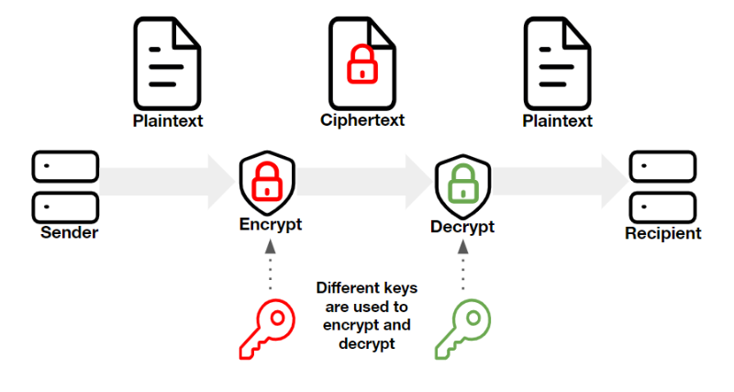
Public keys are discoverable. They are published and are not strictly controlled. The private key however, is known only by its owner. Public keys are paired with an associated private key by generating random numeric combinations of variable length, which makes it difficult for hackers to crack them using brute-force attacks.
Here are some of the benefits of asymmetric encryption:
- Authentication: Asymmetric encryption helps you to verify identities in a way that no one can fake or contest (known as non-repudiation). This process is ideal for encrypting data between third parties who don’t know each other.
- Secure key exchanges: Asymmetric key exchange protocols facilitate symmetric key exchange (more on that below) via public channels that would otherwise be susceptible to man-in-the-middle (MitM) attacks.
- Data integrity: Asymmetric encryption offers assurances that your data hasn’t been altered or modified through the use of digital signatures.
Symmetric key algorithms
PKI is asymmetric by definition, but why doesn’t PKI use two private secret keys instead of one private key and one public key? Asymmetric encryption, which uses two separate keys and more complex algorithms in the encryption and decryption process, is slower for encrypting and decrypting large amounts of data.
Symmetric key cryptography is the process whereby two private secret keys are generated for encryption and decryption. Symmetric encryption is faster and uses only one key, making it great for large organizations and businesses that need to encrypt vast quantities of data. But while it may appear counterintuitive, symmetric algorithms for PKI are less secure because they require both parties, the sender and receiver, to have access to the private secret keys.
This means symmetric encryption is typically best suited for non-public channels, such as those inside an organization, while asymmetric encryption is often used for public channels, such as zero trust networks and the public internet.
PKI benefits
The goal of PKI is confidential and secure communications, by allowing two communicating parties to send and receive sensitive data privately. The benefits of PKI to individuals and enterprises include:
- Protecting customers data privacy
- Securing an enterprise’s intellectual property
- Improving technology compliance
- Preventing compromised data
- Securing remote and distributed workloads
- Protecting large numbers of IoT devices
PKI prevents unauthorized use or access by leveraging cryptographic keys as a validation method to protect digital identities and data. It should be a major part of enterprise cybersecurity programs to protect:
- Websites
- E-commerce transactions
- Documents
- Emails
- Servers
- Other digital assets
PKI is a scalable digital identity security solution that secures billions of daily communications. That scalability is enabled by combining widely distributed public keys with secret private keys that are required to decrypt the message.
Common PKI use cases
PKI technology is applied to applied to wide variety of common use cases, including:
- Web server security: PKI is the basis for the secure sockets layer (SSL) and transport layer security (TLS) protocols, which underpin HTTPS secure web browser connections.
- Digital signatures and document signing: PKI is often used to encrypt messages, but key pairs can be used for digital signatures and document signing by using the sender's private key to verify their digital identity.
- Code signing: Engineers use PKI for code signing as a verification method to ensure their code is safe and can be trusted,
- Email certificates: S/MIME certificates are used to validate the sender and encrypt the message’s contents to protect users from social engineering and phishing.
- Secure shell (SSH) keys: SSH keys are used to authenticate identity and protect services from unintended use or malicious attacks.
- Digital identity: The foundation of a zero trust security strategy is establishing digital identity to authenticate individuals, infrastructure, data, applications, and services.
The role of PKI certificate authorities
The certificate authority (CA) is an important element for deploying X.509 PKI certificates. The CA publishes the public key associated with an individual’s private keys. Trusted CAs make it possible to ensure the sender is using the right public key associated with the receiver's private key. Otherwise, malicious actors could compromise the communications being sent.
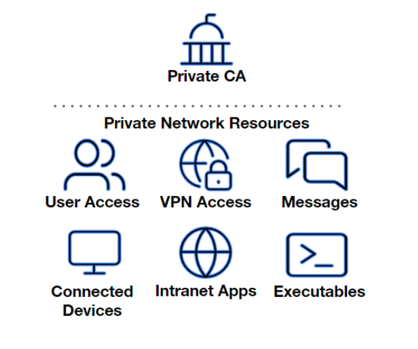
Regardless of the deployment approach, the CA must:
- Verify the identity of all senders’ public keys associated with the CA.
- Ensure public keys are correctly associated with the appropriate private keys.
- Safeguard the organization's data from attacks.
Automating PKI certificate management with HashiCorp Vault
Certificate management may appear to be a mundane task, but manually validating and managing certificates can be time consuming and expensive. Manually provisioning or rotating a certificate for even simple use cases like SSL for a single web server involves multiple steps and can take longer than an hour.
Extrapolate that to provisioning, renewing, and revoking thousands, or millions, of PKI certificates for an organization’s connected devices, workloads, and identities. Manually managing certificates at scale also introduces significant opportunities for human error that could result in system outages, downtime, and even security breaches, further increasing the costs.
Automating certificate management must be a cornerstone of an enterprise’s PKI strategy. HashiCorp Vault Enterprise and HCP Vault allow organizations to establish their own trusted CAs and provide a centralized control plane to manage their certificates and safeguard their internal and external communications. Vault Enterprise allows organizations to self manage their PKI and CA environment, while HCP Vault is a SaaS-based PKI option that lets customers focus on PKI management while HashiCorp manages the infrastructure. Both options let customers tap into HashiCorp’s comprehensive support and customer success programs.
By leveraging protocols like Automated Certificate Management Environment (ACME), HashiCorp Vault enables enterprises to achieve an end-to-end automated certificate lifecycle management (CLM) process that includes certificate provisioning, configuration, rotation, revocation, and deployment. Automating PKI certificate management delivers a clear return on investment (ROI) by reducing risk, achieving regulatory compliance goals, reducing operational costs, and shortening time-to-market.
What is Blockchain Technology?
Blockchain is an online ledger, that makes a secure public record of every transaction made. It uses a computer network, known as nodes, to maintain a growing list of records called blocks.
- Made unalterable data unless an agreement is made by the totality of the network.
- Each block contains transaction details, a timestamp, and the cryptographic hash of the previous block.
- Because the blockchain is accessible, it’s impossible to alter, making it perfect for creating unchangeable documents and building trust in online deals without the involvement of financial institutions or governmental bodies.
- It could be used for the management of supply chains, in voting systems, and helps in digital identity validation.
What Is Blockchain Development?
The development of the blockchain relates to the creation of shared, unchangeable ledgers of recorded transactions and documented assets, both physical, such as money and real estate, as well as immaterial, such as copyrights, within a network. Thus, this technology offers information interchange in an easy, accurate, fast, and secure manner, which will prove to be valuable for many industries. A blockchain network can provide transparency for the delivery and storage of data, such as tracking orders and accounts, payments and production, and more.
- Shared Ledger Creation: Unchangeable, shared ledgers holding all transactions and assets of the network.
- Documentation of Assets: Guaranteeing that all kinds of tangible assets, those of a physical nature, such as money or real estate, along with intangible assets, like copyrights or patents, are managed safely on the ledger.
- Ease of Information Interchange: Easy, accurate, fast, and secure exchange of information.
- Industry Applications: This solution will increase transparency and effectiveness in more industries by tracking orders, accounts, payments, production, and more.
- Transparency of Data: Display transparency in the delivery and storage of data since all transactions and records come under visibility and are provable.
- Security: Security of recorded data and unalterable since this will grant trust and confidence among the people in digital transactions.
- Efficiency Improvement: To reduce the use of intermediaries, streamline processes, and cut costs; this will ensure improvement in operational efficiency.
- Innovation: Develop with changing times to include new development and use cases, catering to the needs of any industry.
How does Blockchain Work?
A blockchain transaction can be broken down into following steps:
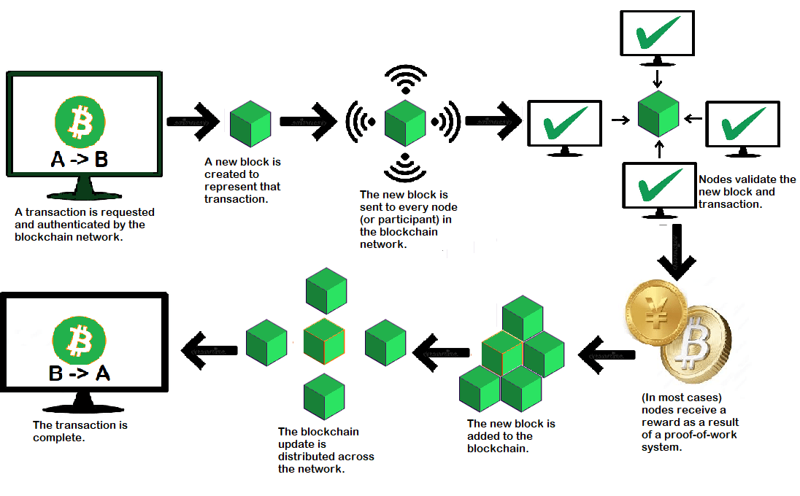
Working of Blockchain
1. Transaction Facilitating
A new transaction is added to the blockchain. All data to be sent is encrypted twice using public keys and private keys
2. Transaction Verification
Now, for verification, the transaction is sent to the global P2P network. All nodes on the network verify the transaction, such as whether there is enough balance to execute the transaction.
3. New Block Formed
In a normal blockchain network, there are lots of nodes, and lots of transactions are verified at once. Once a transaction is validated and declared a valid transaction, it is added to the new block. All the validated transactions at a given node make up a mempool. Multiple mempools make up a block.
4. Consensus Algorithm
Nodes that make up a block will attempt to add it to the blockchain network so that it becomes permanent. However, if each node can go ahead to create blocks like that, it would disrupt the entire operation of the blockchain network. For that reason, there are consensus mechanisms by which nodes enforce that any new block added to the blockchain is the only version of truth agreed upon by every node in the blockchain. Only a valid block can be securely added to the blockchain. The node that is chosen to add a new block to the blockchain gets a reward. This is why we call them miners. The consensus algorithm generates a hash code for each new block that is needed to add the block.
5. Adding the New Block to the Blockchain
Installing a new block into the blockchain. After the new block has been confirmed and assigned its hash value, it is prepared to be added to the blockchain. Every block includes a hash value from the block before it, and these blocks are cryptographically connected to form a blockchain.
6. Transaction Complete
Once the new block has been confirmed and assigned its hash value, it is ready to be used in the blockchain. Each block will contain the hash value from the block that came before it, with these blocks cryptographically linked together in a chain to form a blockchain.
History of Blockchain
1991: Researchers Stuart Haber and W. Scott Stornetta introduce Blockchain technology to timestamp digital documents securely using cryptography.
1992: Merkle Trees enhance the original system, making blockchain more efficient for storing multiple documents in a single block.
2000: Stefan Konst publishes a theory on cryptographically secured chains and implementation ideas.
2004: Hal Finney developed “Reusable Proof of Work” to solve the double-spending problem in digital cash systems.
2008: Satoshi Nakamoto presents “Distributed Blockchain” in a white paper, which is the conceptual basis for Bitcoin.
2009: Satoshi Nakamoto publishes the Bitcoin white paper, the first document of blockchain in a wider application.
2014: Blockchain technology develops beyond digital currency; the beginning of the development of Blockchain 2.0 for various industries.
2015: Launch of the Ethereum Frontier Network; enabled smart contracts and dApps; Linux Foundation launches Hyperledger project.
2016: Term “Blockchain” becomes a single word; Ethereum hard fork due to a DAO code bug; Bitfinex hack.
2017: Bitcoin becomes legal in Japan; Block.one introduces EOS blockchain for commercial dApps.
2018: Bitcoin turns 10; value goes down to $3,800; Google, Twitter, and Facebook ban cryptocurrency ads.
2019: Ethereum network transactions exceed 1 million per day; Amazon launches its Managed Blockchain service on AWS.
2020: Digital currencies gain widespread appeal; Ethereum begins transitioning to Ethereum 2.0 with Beacon Chain.
2022: Ethereum shifts from Proof of Work to Proof of Stake, significantly cutting down on its energy use.
Use Case of Blockchain
The technology is being utilized in various sectors such as logistics, healthcare, retail, media and marketing, finance, insurance, travel and transportation, oil and gas, and even the gaming industry. Here are some applications of blockchain:
1. Digital Currency
The concept of blockchain, in the first place, was developed to manage digital coins in the likes of bitcoin. Since digital coins are kept under wraps, blockchain is a feasible system for keeping the transactions accurately and confidential to the parties involved. However, the 2022 crypto winter, as it is known to be at the present, has put digital money in hot waters claiming fraud, declaring bankruptcy in swarms, and crashing more than its original value, and has the government at arms asking for regulations. Some examples include Polkadot, NEO, Cardano, Tether, Binance Coin, and Litecoin – to name but a few – besides Bitcoin and Ethereum.
2. Smart Contracts
These are self-executing blockchain applications that are carried out without a middleman, in the case of fulfillment of certain requirements by the parties.
3. Decentralized Banking
Blockchain technology is finding increasing application in banking. For example, a host of banks, such as Barclays, UBS, and Canadian Imperial Bank, all take an interest in how blockchain technology can optimize their back-office settlement processes.
4. Video Games and Art
You may have heard about Crypto Kitties, an Ethereum blockchain game. There, a digital pet changed hands for over $100,000.
5. Peer-to-Peer Energy Trading
In this direct form, energy is bought or sold from one party to another, cutting out the middlemen. Blockchain has also been applied to traceability in supply chain logistics, tracking the provenance of goods and precious metals. Walmart, working with IBM, developed a food traceability system based on open-source ledger technology for traceability in the event of contaminated food.
6. Healthcare Process Optimization
Blockchain can expedite the time needed to store and securely exchange medical data and records, as well as pay patients’ health insurance bills.
7. Platform for Processing Real Estate Transactions
The blockchain allows for the safe storage and verification of property ownership data. You may more quickly confirm property ownership and have peace of mind knowing that these documents are accurate because they can’t be altered.
8. NFT Marketplaces
These are online stores where you can purchase digital tokens representing items like apparel and artworks, also known as nonfungible tokens, or NFTs. Blockchain technology allows for the tracking of music streams and the instant payment of song contributors.
9. Anti-money Laundering Tracking System
Because every transaction on the blockchain is recorded and creates a tamper-proof trail, authorities may more easily track the money’s original source.
Types of Blockchain
There are various types of blockchain technology. Every type of blockchain has unique features and applications.
1. Public Blockchain
In a public blockchain, any person can be a node in a decentralized network. Public blockchains are accessible to everyone, and anyone can view the transactions. Furthermore, the records of the transactions on the blockchain are kept forever. However, the widest field of application for the public blockchain remains in cryptocurrency, for example, Ethereum and Bitcoin. Among several advantages associated with public blockchains are awesome safety, ease of usage, and decentralized networks. However, there are various drawbacks to public blockchains, such as the high consumption of energy and scaling issues due to the time the transactions take and the number of transactions that it can handle.
2. Private Blockchain
A private blockchain is a network where only permission nodes can enter the network. The major applications of private blockchains come at business and organizational levels as they ensure protection and keep sensitive data confidential. In a private blockchain, the participant nodes are known among each other, and the transactions are validated by a set of pre-selected nodes. The other advantages of private blockchains, like greater privacy, faster transaction times, and higher scalability, are as well the main pros. The reason why private blockchains are less secure than public ones is that the validation process is centralized.
3. Hybrid Blockchain
Hybrid blockchains fall into one of two categories: public and private. Public blockchains allow the public to view some parts of a blockchain, while private blockchains keep some parts private. For example, it can place data considered public in nature in a blockchain, such as one housing a cryptocurrency ledger. On the other hand, confidential data, such as a medical file, would go on a private blockchain.
4. Consortium Blockchain
A consortium blockchain is a variety of private blockchain where transactions are approved by several cooperating organizations. Most commonly, consortium blockchains are applied to industries that require access to and validation of several parties’ data—for example, supply chain management, banking, and healthcare. In a consortium blockchain, the management of the network is held by a set of pre-selected nodes, and the collaborating organizations will have a say in how the validation process is conducted.
5. Permissionless Blockchain
On a kind of public blockchain known as a permissionless blockchain, any person can join the network as a node. Most permissionless blockchains are applied in decentralized apps that help a user generate, deploy, and use programs without intermediaries. The benefits that are accrued from permissionless blockchains are that they are very open, decentralized, and secure. However, private blockchains will tend to be more scalable and fast than permissionless blockchains. Public blockchains and permissionless blockchains basically differ from one another in control over access. On a public blockchain, everybody who wants to join the network can do so. Contrary to this, only authorized persons can access the information on a permissionless blockchain.
Benefits of Blockchain Solutions
- Trustless: Trusted transactions between counterparties that do not need to know one another are automated by the immutable blockchain. Only when both parties fulfill the predetermined conditions will a transaction be carried out.
- Unstoppable: A transaction that has been started cannot be reversed, altered, or stopped after the requirements built into the blockchain protocol have been fulfilled. Nothing, not even a bank, the government, or a third party, will be able to stop it from executing.
- Unchangeable: Data stored on a blockchain is unchangeable and unhackable; Bitcoin has never experienced a hack. A consensus method solves and verifies a difficult mathematical problem before adding a new block of transactions. Every each block has a distinct cryptographic key that is generated by adding the data and key from the previous block to a formula.
- Decentralized: The network is not maintained by a single party. On the blockchain, decisions are reached by consensus, unlike with centralized banks. Decentralization is necessary to guarantee that there are multiple points of failure and that users may readily access and develop on the platform.
- Reduced Cost: Reducing wasteful spending can help you expand faster and improve your profits. Blockchain eliminates the need for third-party middlemen, without sacrificing trust or accuracy. Everything is verified by network members by consensus, so you don’t have to waste valuable time examining trade documents.
- Peer-to-peer: You may transmit money directly to anybody, anywhere in the world, using cryptocurrencies like Bitcoin, eliminating the need for a middleman like a bank that would charge transaction or processing fees.
- Enhanced transparency: When a transaction takes place, the network has to validate it, which means that all parties involved have to concur that the hash and other associated data are accurate. If this is the case, the transaction is considered valid. All network users can thus view the complete history of every transaction on the distributed ledger. Information is always correct, safe, and visible to all members because each update made to one record affects all subsequent records as well.
- Lower risk of fraud: Transactional histories can be complex for any kind of business, especially when assets are traded or sold regularly and change hands or locations. Everything is instantly accessible as a complete audit trail that provides insight into the past of an asset when it is all stored on a blockchain. On the blockchain, every past transaction record is immutable, preventing fraud and confirming legitimacy.
- Enhanced speed and efficiency: You’re probably squandering valuable time that you should be using on higher-value tasks if you’re still handling transactional records by hand using antiquated techniques (such as paper documents, spreadsheets, or third-party systems). These conventional methods are prone to errors and necessitate laborious repetitions in order to guarantee precision. By automating and streamlining the procedure, blockchain ensures that all parties are operating from the most recent ledger, removing workflow bottlenecks.
Globally, two billion people lack bank accounts due to universal banking. The blockchain is a fantastic tool to bank the unbanked and guard against theft that might occur from keeping currency in physical locations because anyone can access it to store money.
Blockchain Development Challenges
As the blockchain ecosystem matures and new use cases arise, blockchain developers will confront three major challenges: security, scalability, and decentralization. Known as “the blockchain trilemma,” developers are challenged with identifying solutions to these difficulties without incurring trade-offs.
1. Decentralization
Decentralization is one of the primary reasons industries utilize blockchain. In the financial arena, for example, blockchain solutions enable users to store and acquire Bitcoin without giving banks complete control over their assets. Instead, transactions are validated through consensus (a collection of notes rather than a single node). Once verified, these transactions are irreversible.
The cost of decentralization is the time it takes for several confirmations to establish a consensus. Finding a way to accelerate this process is a problem for blockchain engineers.
2. Scalability
Global blockchain adoption is dependent on its ability to handle an increasing number of transactions as demand grows—all while performing as expected and securing itself against hackers. Once again, speed is a trade-off, particularly as block sizes increase.
In order to lessen the danger of cyber threats, Bitcoin originally imposed a 1-megabyte block size limit. However, each coin can record an endless number of transactions, each of which increases the size of the block. As a result, blocks may eventually exceed any size constraints imposed on them, further slowing processing speed.
Although Bitcoin started the block-size issue, all blockchain apps will be impacted as developers determine whether to raise block size while maintaining speed.
3. Security
While one advantage of blockchain development is security, there are drawbacks as well for programmers. Cybercriminals pursue blockchain because they believe it to be a very secure technology. Anything that compromises blockchain security will have a cascading effect that puts decentralization and scalability at risk. Furthermore, in the event of a security breach, there would be no centralized party to step in without regulatory scrutiny.
Blockchain security breaches are uncommon, although people have taken advantage of recognized flaws in its architecture. Blockchain networks that guarantee total security and bring economic value must be built by developers.
Though creating a blockchain solution presents certain difficulties, it’s vital to keep in mind that the technology is still in its infancy. Since technology is always advancing, there is a strong justification for blockchain development in general.
4. Cybercriminals and Illicit Trading
The blockchain sector is missing a comprehensive regulatory framework, rendering it unstable and susceptible to manipulation in the market.
For example, the notorious case of the one coin fraud, where numerous investors believed it to be the future of digital money, turned out to be a fraudulent Ponzi scheme. Even if you’re well-versed in cryptocurrency, there’s always a risk that your online wallet could be compromised or shut down by authorities for engaging in questionable activities.
5. Cost
Blockchain is typically set up to reduce the costs associated with third parties and intermediaries in the value transfer process. Although, blockchain technology offers significant advantages, it is still in its early development phase, which complicates its integration into existing systems. This complexity increases the overall cost, deterring both government agencies and private companies from adopting it.
How to Recognize When to Implement Blockchain Development?
Although blockchain has many advantages, it’s important to remember that not every platform or company can profit from it. Asking the following important questions is usually a good idea before deciding if blockchain development is the correct fit for you:
1. Do you Require a Location to Keep Data?
- If this is the case, you might not have to adopt blockchain right away. E
- Examine the amount of data you genuinely want to save first. For instance, if you own a tiny firm, you can probably get by with just local data storage and it won’t be worth the expense.
- On the other side, blockchain can provide you with a fully transparent, current ledger that’s simple for everyone to work from if you run an enterprise-scale organization that needs large data storage, upkeep of several databases, and access for numerous people.
2. Does Sharing and Updating of your Data Need to Happen Often?
- The time-consuming procedures involved in manual and paper-based data management can be decreased with blockchain development.
- Assume that your company relies heavily on historical data that is always evolving.
- Then, a blockchain solution that automates the procedure, permits numerous entries from different authorized individuals, and guards against data alteration would be required.
3. Are Transactional Speeds Becoming Too Slow for Your Business?
- Blockchain can eliminate obstacles that impede some activities, but without an accelerator, it typically doesn’t provide very fast transactional speeds.
- A blockchain solution makes more sense if application security is your top concern and transaction speed is not.
4. Do you Require Permission from a Third Party?
- For the sake of data control and verification, certain enterprises need an intermediate.
- Blockchain won’t make sense for them. But blockchain can offer complete transparency and consensus confirmation for companies that don’t rely on outside solutions.
- It also lessens the expenses and wait times associated with doing transactions through an intermediary.
Analog and digital signals are two fundamental types of electrical signals used to transmit information in various electronic systems. Analog signals are continuous and vary smoothly over time, while digital signals are discrete and represented by a series of discrete values.
Understanding the difference between these signals is important in telecommunications, electronics, and signal processing. In this article, we will go through the difference between analog and digital signals.
Table of Content
- What is an Analog Signal?
- What is Digital Signal?
- Difference Between Analog And Digital Signal
What is an Analog Signal?
Analog signal is a type of signal that represents continuous data using a continuous range of values. In other words, it can take on any value within a certain range. Analog signals are characterized by their smooth and continuous nature.
For example, imagine a sound wave. In analog form, the sound wave is represented by a continuously varying electrical signal that mirrors the fluctuations in air pressure caused by the sound.
What is Digital Signal?
Digital signal is a type of signal that represents data as a sequence of discrete values, typically using binary numbers, it also contain different voltage values. Unlike analog signals, which vary continuously over time, digital signals are discrete and quantized, meaning they only take on specific, distinct values.
In digital communication and computing systems, information is encoded into digital signals for transmission, processing, and storage. These signals are commonly used in telecommunications, audio and video processing, computer networks, and many other applications.
Difference Between Analog And Digital Signal
The difference between analog signal and digital signal could be understood from the table given below:
Basis | Analog Signal | Digital Signal
Definition | Analog signals represent continuous variations in magnitude over time. | Digital signals are Discrete and quantized, with specific values.
Signal Type | Continuous waveforms | Discrete Signals
Processing | Requires complex processing for manipulation. | Easier to process and manipulate digitally.
Storage | Less efficient for storage due to continuous nature. | More efficient for storage due to discrete values.
Bandwidth | Typically requires more bandwidth. | Requires less bandwidth for transmission.
Examples | Analog audio signals, analog radio waves, Human voice, etc. | Digital audio signals, digital data streams, computers, etc.
Errors | Susceptible to noise and distortion | More resistant to noise and distortion
Circuit Component | Amplifiers, filters, continuous-wave oscillators | Microprocessors, binary counters, logic gates
Signal Values | Infinite range of values | Limited to discrete values
Conversion | No conversion required | Analog-to-digital conversion (ADC) required
Applications | Analog signals are used in electric fan, landlines, radio frequency communications, etc. | Digital signals are used in computers, smartphones, digital sensors, digital imagining, etc.

Sensor types in IoT applications
- Analog sensors
  - Advantages
    - Provide precise, high-resolution data suitable for measuring continuous phenomena (temperature gradients, pressure changes)
    - Offer a wide range of values allowing for detailed analysis and control
  - Disadvantages
    - Require additional circuitry for signal conditioning (amplification, filtering) and analog-to-digital conversion
    - More susceptible to noise and interference from external sources (electromagnetic fields, power line noise)
- Digital sensors
  - Advantages
    - Directly compatible with digital systems and microcontrollers simplifying integration and data processing
    - Less susceptible to noise and interference due to binary nature of the output signal
    - Easier to interface and process data using standard communication protocols (I2C, SPI)
  - Disadvantages
    - Lower resolution compared to analog sensors limiting the level of detail in the measured data
    - May require more complex communication protocols and timing considerations for reliable data transfer

